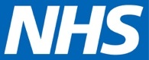
COVID-19 VACCINATION DEPLOYMENT PROGRAMME

Communications materials: Vaccinating young people aged 16 and 17

The following template materials are designed to support primary care communications around the vaccination of young people aged 16 and 17 in line with JCVI guidance announced on 4 August 2021 and a related letter of 5 August 2021 from NHS England and NHS Improvement.

These templates can be used/tailored as appropriate, and we thank you for supporting the COVID-19 vaccine rollout.

- Key messages

- National press release (issued 19 August)

- FAQs

- Further resources

- Key messages

- In line with JCVI guidance on 4 August, the NHS has invited all young people aged 16 and 17 to receive a first dose of the COVID-19 vaccination.

- The NHS has invited all young people aged 16 and 17 to receive a first dose of the COVID-19 vaccination. You can find your nearest NHS walk-in vaccination centre at www.nhs.uk/grab-a-jab

- The COVID-19 vaccines are available free of charge for everyone aged 16 and over.

- The first dose has been shown to provide 80% protection against hospitalisation. Protection could be even higher as younger people respond better to vaccines and some will already have had the COVID-19 infection, meaning they will have an even better response to a first dose.

- Getting vaccinated means protecting yourself from the virus so you can keep safe and be there for your family and friends.

- The COVID-19 vaccinations do not contain animal products and have been approved by the MHRA, the official UK regulator, like all other medicines and devices. This means we are confident they are safe and effective.

- The vaccines have undergone months of rigorous testing, including with people from a range of ethnic backgrounds and health conditions, and are recommended for the vast majority of people.

- National Press release (issued 19 August)

COVID-19 jab invite letters sent to one million 16 and 17 year olds
Invitations to get a COVID vaccine are landing on the doormats of all 16 and 17 year olds from today, in a further effort to boost take-up in this age group, as the biggest and most successful vaccination programme in NHS history expands further.

Over 360,000 people aged 16 and 17 have already had their jab – which includes those who were eligible previously eligible due to an underlying health condition, with more than 125,000 getting their jab in the two weeks since the NHS was given the green light to offer all 16 and 17 years olds the life-saving jab.
The JCVI updated guidance on 4 August so that all 16 and 17-year-olds could be offered one dose of the vaccine, and anyone in this age group can now find their nearest centre through the ‘grab a jab’ NHS online walk-in finder, with more sites becoming available every day.

GPs are also inviting at-risk children aged between 12 and 15 years old, who are clinically vulnerable to COVID or live with adults who are at increased risk of serious illness from the virus, with 30,000 children in this age group already protected.
NHS staff have delivered well over 74 million doses, since the NHS in England administered the first jab outside of clinical trials to Maggie Keenan in December 2020, and more 34 million adults are have now received both jabs.
Professor Sir Keith Willett, Head of the COVID-19 Vaccination programme in England, said: “Thanks to the dedication and hard work of NHS staff, and the teenagers who have already come forward for their jabs, the NHS has administered more than 125,000 first doses of the COVID-19 vaccine to 16 and 17-year olds, protecting themselves, their families, and their friends from the virus.

“The vaccine is safe and effective with nearly nine in 10 adults already taking up the offer, and I would urge anyone eligible, especially those 16 and 17 year olds heading back into education or training, to get their life-saving jab.”
Health and Social Care Secretary Sajid Javid said: “It is excellent to see the enthusiasm young people have shown to get a COVID-19 vaccine and help to build our wall of defence against this virus.

“I urge you to join the hundreds of thousands of 16 and 17 year olds who have already taken up the offer of vaccine as quickly as possible to ensure you get vital protection before returning to college or sixth form.
“Please don’t delay – vaccines are allowing us to live safely with this virus without restrictions and enjoy our freedoms.”
The NHS has been jabbing at hundreds of convenient locations across the country, including mosques, museums, football stadiums and other community hubs, as well as a number of pop-up clinics at shops, festivals, and locations like Thorpe Park.
- FAQs for the general public

My child is in one of the eligible groups. How do I arrange his/her vaccination?

If your child is in one of the new groups recommended for vaccination by the JCVI, you will be contacted by the NHS before then to arrange for your child’s vaccinations.

16 and 17 year olds are being contacted directly by letter, followed up by text messages from 20 August.

If your child is within three months of turning 18, they will be invited directly to book an appointment via the National Booking Service at the appropriate time and may also be invited via local vaccination services.

There is no need for individuals to approach their GP or other local NHS services before they receive a letter or text. Those age 16 to 17¾ will not be able to use the National Booking Service, although they can find a convenient walk-in site near to where they live at www.nhs.uk/grab-a-jab.

How do I know the vaccine is safe for my child?

The JCVI has reviewed extensive clinical evidence for the safety of giving the COVID-19 vaccine to children and young people in the eligible groups and have determined it to be safe and effective. The JCVI has determined that the benefit of vaccinating children in these groups outweighs the risks.

Which type of COVID-19 vaccination should 16-17 year olds be offered?

The Pfizer-BioNTech BNT162b2 vaccine is the only vaccine authorised for those aged 16 and 17¾. At this time, JCVI advises that 16-17 year olds should be offered a first dose only. (alongside the existing offer of two doses of vaccine to 16 to 17 year olds who are in “at risk” groups).

What about a second vaccine?

It is anticipated that a second dose will be offered later on, to increase the level of protection and contribute towards longer term protection. This will follow further work on effectiveness and safety in this age group, after which the JCVI will provide further guidance on whether a second vaccine dose should be offered to healthy 16 to 17 year-olds. This is expected to be made before second doses are due at approximately 12 weeks after the first dose.

Young people who are called as part of the 16-17 year old programme and receive their first dose above the age of 17 years and 40 weeks may be scheduled to receive their second dose after an interval of at least eight weeks, as part of the “turning 18 programme”.

Are any children under 16 eligible for a vaccine?

As well as 16-18 year olds, the following groups of children and young people are also eligible, following previous JCVI advice:
  - 12-15-year olds ‘at risk’ with the underlying health conditions specified below:
- severe neuro-disabilities,
- Down’s Syndrome,
      - underlying conditions resulting in immunosuppression, and
      - those with profound and multiple learning disabilities, severe learning disabilities or who are on the learning disability register
- Children aged 12 years and older without underlying medical conditions who are household contacts of individuals (adults or children) who are immunosuppressed.

My child is not in one of the eligible groups. When will they be able to be vaccinated?

There are no current plans to vaccinate children and young people outside of the eligible groups. However, the JCVI is continually reviewing evidence on this matter and will advise the Government if it decides that a change of approach is required.

Why is the NHS only vaccinating some children and young people against COVID-19, and not all?

The NHS vaccinates in line with guidance from the independent JCVI (Joint Committee on Vaccination and Immunisation), which provides expert advice on vaccinations to UK health departments. The JCVI recommends that only certain groups of children and young people are vaccinated because of a combination of factors including their risk of getting seriously ill from coronavirus, passing it to others who may become seriously ill, and evidence of safety and effectiveness.

- Further resources

Multimedia campaign assets to encourage younger people to get the vaccine

Shareable video explaining the benefits of the vaccine

Videos with our NHS people talking about why it is important to get the jab

Dr Ammalina Bakri Insta Live Q&A on vaccine hesitancy

Young NHS volunteer explains why she now feels confident getting the vaccine

NHS video: every vaccine gives us hope

NHS video: what is the vaccine and how does it work?

SE London ICS video: Tyrick’s Story

SE London ICS video: Olie and Kadi’s story

Videos in community languages about disinformation

Main link on the NHS website for the public to find out more information about the vaccine

FAQs for operational colleagues in the NHS (13 August 2021)

Added 24 August:

NHSE presentation to Association of Colleges 26/08/21 with call to action.
Targeted local comms to colleges mapped to areas of low uptake:

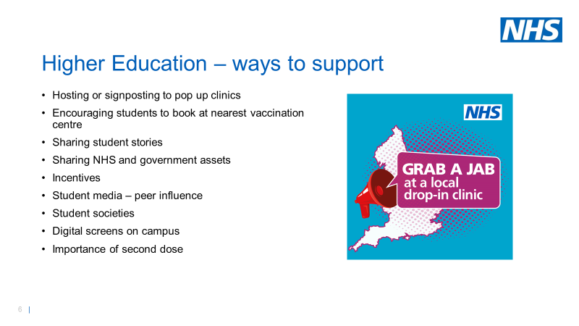

- Social media assets delivered, more in production including interviews and visual case studies / ‘voice pieces’ with 16 and 17s explaining why they have had/will be getting vaccination, with potential for media package

- DHSC/Freuds film presented by Dr Emeka about young people with Long Covid YouTube and Vimeo, and MP4 version to feature across NHSE social media and Regional comms channels

- Reading and Leeds Festivals – pop up vaccination centres, information tents, clinical staff for conversations. Vaccination messages and social media assets shared via festival comms, on festival screens during festival, and through festival app. National media coverage for weekend.

- Targeted messaging to employers of 16/17s – supermarkets and clothing retailers

- Approved Driving Instructors Joint National Council – briefing for members and sharing of messages/assets for Driving Schools’ websites and social channels

- Association of Convenience Stores - briefing for members and sharing of messages/assets for Driving Schools’ websites and social channels

